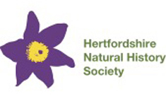
Herts Natural History Society 1875 and Trevor James Awards
Nomination Form 2026
The 1875 Award recognises someone who has made an outstanding voluntary contribution to natural history in Hertfordshire. The name of the award commemorates the founding of the Society in 1875.
The Trevor James Award recognises an outstanding Hertfordshire naturalist. The award was named in 2021 to commemorate the late Trevor James's remarkable contribution to wildlife conservation and recording in the county over more than 50 years.
Nominee
Nominated by
Please summarise the nominee's contribution to natural history in Hertfordshire. Their contribution should be in a voluntary capacity | Maximum 300 words
How are they recognised as experts in their field?
For how long have they contributed to natural history in Hertfordshire?
What are their key achievements? eg activities, projects, papers, publications,
Have they been involved in training or educating others in the natural history of Hertfordshire?
How have they championed the natural history of Hertfordshire?
Are they members of Hertfordshire Natural History Society?

